**Customer Service Excellence**

**Module 1**

**Building Trust with Clients**

*(Jinnar Certificate Training – Customer Service Excellence)*

**1. Why Trust Matters**

When customers trust you, they:

* **Give you more jobs in the future** – A happy client becomes your regular customer, meaning steady work without the need to chase new leads.
* **Recommend you to friends, family, and neighbors** – Word-of-mouth is free advertising, and trusted workers often get jobs without spending a shilling on marketing.
* **Pay you fairly without arguments** – Trust reduces disputes over payment, so you get your money on time and in full.
* **Allow you to work without supervision** – A trusted worker doesn’t need someone watching over their shoulder; the client is confident in your skills and honesty.
* **Offer bigger and better projects** – Clients are more likely to give important, higher-paying jobs to someone they trust.
* **Forgive small mistakes** – Everyone makes mistakes, but a trusted worker gets understanding instead of complaints.
* **Share positive reviews on the Jinnar platform** – Trust leads to higher ratings, which attracts more customers.

💡 **In the informal sector, trust is often more valuable than the price you charge.** It’s the invisible currency that opens doors, builds your reputation, and keeps your calendar full.

**2. Ways to Build Trust**

**A. Keep Your Promises**

* Arrive at the agreed time or earlier — being on time is a sign of respect.
* Finish work within the agreed period, or update the client immediately if delays happen.
* Keep small promises too (e.g., calling back at a set time, sending a receipt).

**Example:**  
If a rainstorm delays your roofing work, call or message the client right away:

“I’m sorry, the weather has made it unsafe to continue today. I will be back tomorrow morning to finish.”

**Why it matters:** Clients remember reliability more than speed — consistent promises kept build a reputation for dependability.

**B. Be Honest About Your Skills**

* Accept only jobs you know you can complete at a high standard.
* If a job is outside your expertise, connect the client to a reliable colleague.
* Don’t experiment on a client’s job without their permission.

**Example:**  
If you’re a plumber and the customer asks for electrical repairs, say:

“Electrical work is not my main skill, but I know a good electrician who can help.”

**Why it matters:** Honesty prevents mistakes, protects your reputation, and shows you care more about the client’s results than just the payment.

**C. Show Respect in Communication**

* Use polite language at all times, even when under stress.
* Listen without interrupting.
* Acknowledge the client’s concerns before replying.

**Example:**  
Customer: “Why are you late?”  
Worker: “I’m sorry, the bus broke down. I should have called earlier to let you know.”

**Why it matters:** Good communication can turn a frustrated client into a loyal one.

**D. Protect the Customer’s Property**

* Use dust sheets, covers, or tape to shield areas from damage.
* Move fragile items out of harm’s way before starting work.
* Clean up after yourself — leave the place better than you found it.

**Example:**  
If painting a room, cover furniture with plastic and tape off skirting boards to prevent splashes.

**Why it matters:** A client who feels their home is safe with you will invite you back.

**E. Do Quality Work Every Time**

* Treat small jobs as seriously as large projects.
* Double-check your work before saying it’s finished.
* Use proper tools and materials to avoid quick breakdowns.

**Example:**  
A customer will remember a perfectly fixed kitchen hinge just as much as a house renovation — because it solved their problem without further trouble.

**Why it matters:** Consistent quality leads to consistent business.

**F. Be Transparent About Pricing**

* Discuss the price in detail before starting.
* If there’s a change in cost, explain why and get approval first.
* Give a breakdown of what’s included so the client feels informed.

**Example:**

“While fixing your tap, I found the pipe is broken. Replacing it will cost TSh 5,000 more. Would you like me to continue?”

**Why it matters:** Clear pricing prevents disputes, builds confidence, and increases the chance of repeat work.

**3. Jinnar Trust-Building Checklist**

*Follow these every job, every time*

1. **Be Punctual** – Arrive on time or earlier. Timekeeping shows respect and professionalism.
2. **Be Polite** – Use kind, respectful words, even under pressure.
3. **Keep Your Word** – Deliver exactly what you promise — no excuses.
4. **Work with Care** – Leave every job site clean and your work safe, strong, and neat.
5. **Be Honest** – Tell the truth about your prices and skills before starting.
6. **Respect Every Space** – Treat the customer’s home or business like your own.
7. **Communicate Clearly** – Update the client before, during, and after the job.
8. **Deliver Quality** – Whether small or big, every job gets your best effort.

**4. Common Mistakes That Damage Trust — and How to Avoid Them**

1. **Accepting a job without understanding it fully**
   * **Why it’s bad:** Leads to poor results, unhappy customers, and negative reviews.
   * **Jinnar Standard:** Ask detailed questions, confirm the client’s needs, and accept only jobs you are confident you can do well.
2. **Taking too long without updating the customer**
   * **Why it’s bad:** Makes customers feel forgotten or cheated.
   * **Jinnar Standard:** If a delay happens, call or message immediately to explain and give a new timeline.
3. **Changing prices after the work without explaining why**
   * **Why it’s bad:** Feels like dishonesty and breaks trust instantly.
   * **Jinnar Standard:** Discuss any cost changes *before* continuing the job, with a clear reason and customer approval.
4. **Leaving a mess after the job is done**
   * **Why it’s bad:** Shows lack of respect and professionalism.
   * **Jinnar Standard:** Always clean your work area — leave it looking better than when you arrived.
5. **Arguing with customers instead of finding solutions** *(New)*
   * **Why it’s bad:** Turns small problems into big ones and can lead to public complaints.
   * **Jinnar Standard:** Stay calm, listen, and suggest fair solutions.
6. **Not showing up for an agreed job without notice** *(New)*
   * **Why it’s bad:** Damages your personal reputation and the Jinnar brand.
   * **Jinnar Standard:** If you can’t make it, inform the client early and reschedule professionally.

💡 **Remember:** Every job you do represents not just you, but the Jinnar platform. Your professionalism builds our shared reputation — and unprofessional behavior can harm both your future work and the trust in our brand.

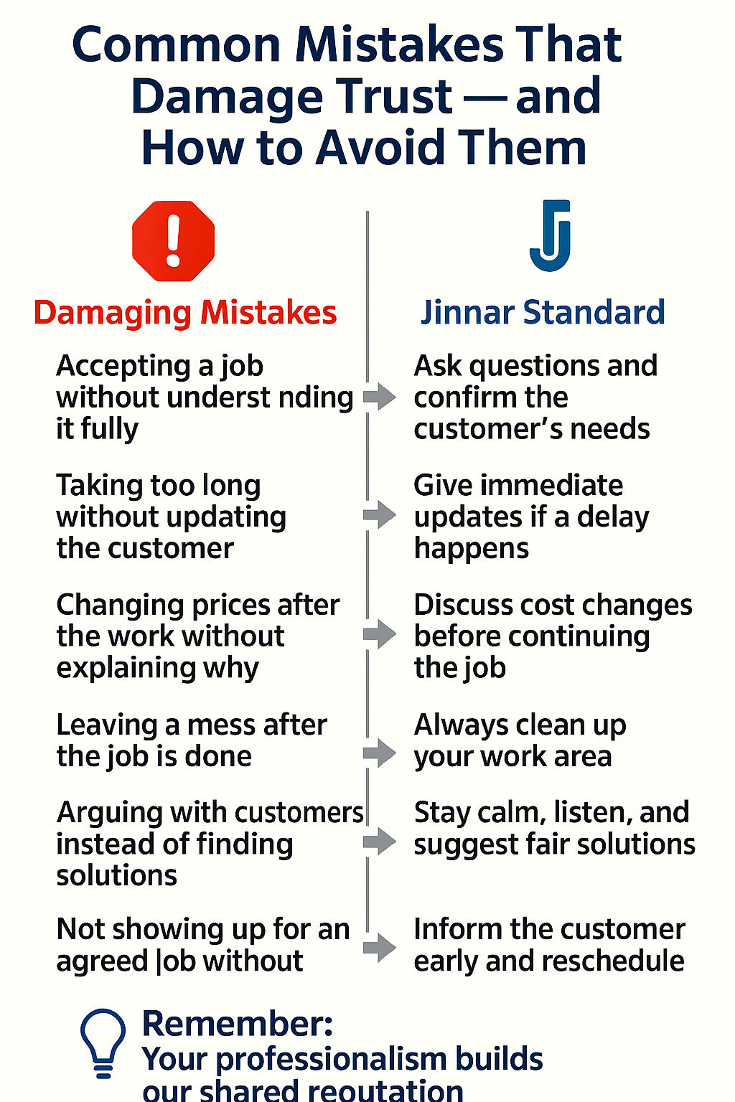

**5. The Jinnar Trust Advantage**

**On the Jinnar platform, trust isn’t just a value — it’s your greatest asset.**

* **Your ratings and reviews are your public badge of credibility.** Every satisfied customer leaves behind proof that you are reliable, skilled, and worth hiring again.
* **Trust opens the door to more work.** The higher your trust score, the more often you appear in searches, and the more customers choose you over others.
* **Good habits are rewarded.** Arriving on time, keeping promises, and treating clients respectfully can push you to the top of the job listings.
* **Poor behavior limits your opportunities.** Missed deadlines, unprofessional conduct, or disputes can lower your ranking and reduce your job offers.
* **Your reputation stays with you.** Jobs you do today directly impact the work you’ll get next month, next year, and beyond.

💡 **Remember:** On Jinnar, skill gets you noticed, but **trust gets you chosen again and again.**

On the Jinnar platform:

* Your **ratings and reviews** show customers you are trustworthy.
* **Bad behavior** can lower your visibility, but good trust-building habits will help you appear in more searches and get more jobs.

If you want, I can create **a simple, visual “Trust Pyramid” infographic** for this lesson — showing the six main trust-building actions stacked from the most basic to the most advanced — so workers remember them easily.

Do you want me to prepare that infographic next?

Ask ChatGPT

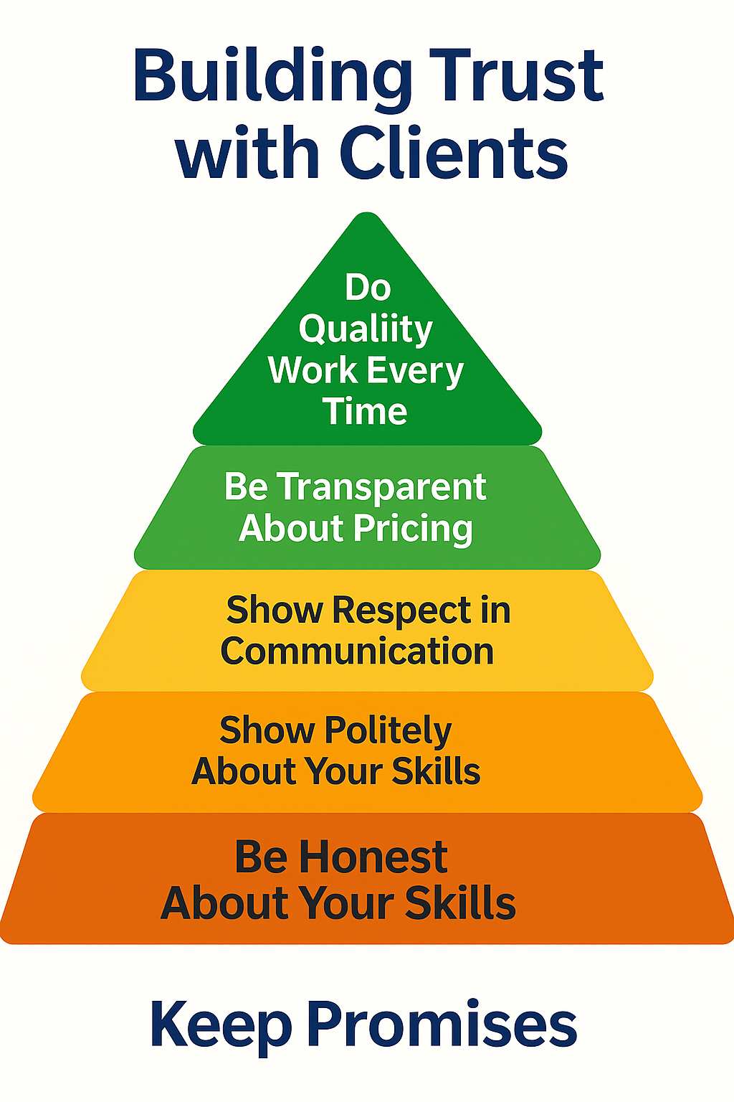

**Module 2**

**Handling Complaints Politely and Effectively**

*(Jinnar Certificate Training – Customer Service Excellence)*

**1. Why Complaints Matter**

Complaints are not just criticism — they are a chance to:

* Fix a problem
* Keep the customer’s trust
* Learn and improve your service

💡 *If you handle a complaint well, the same customer may still hire you again.*

**2. Golden Rules When a Customer Complains**

**A. Stay Calm and Listen**

* Let the customer finish talking without interrupting.
* Show you are paying attention — nod, keep eye contact, and listen carefully.

**Example:**  
Customer: “The paint is peeling already.”  
Worker: “I understand, please tell me exactly when it started.”

**B. Stay Polite – Even if You Disagree**

* Never raise your voice or insult the customer.
* Use respectful language, even if you feel the customer is wrong.

**Example:**

“I’m sorry to hear this. Let’s see how we can solve it together.”

**C. Repeat the Problem Back to Them**

This shows you understand.  
**Example:**

“So you are saying the water pipe I fixed is still leaking after two days, correct?”

**D. Offer a Solution or Next Step**

* If you can fix it right away, tell them when and how.
* If it will take time or cost extra, explain clearly.

**Example:**

“I can come tomorrow at 9:00 AM to repair it. There will be no extra charge.”

**E. Keep Your Promise**

* If you agree to fix it, do it on time.
* Follow up to confirm the customer is satisfied.

**Example:**  
After fixing:

“I just wanted to check if the repair is holding well now.”

**3. Step-by-Step Method for Handling Complaints (Jinnar Standard)**

**1. Listen Actively and Respectfully**

* Give the customer your full attention, without interrupting.
* Use body language or short verbal cues (“I understand,” “I see”) to show you are listening.

**2. Stay Calm and Professional**

* Keep your tone friendly and respectful, even if the customer is upset.
* Avoid reacting emotionally or defensively.

**3. Confirm Your Understanding**

* Repeat the customer’s concern in your own words:  
  *“So you are saying the paint color looks different from what was agreed, correct?”*

**4. Acknowledge and Appreciate**

* If it’s your mistake, apologize sincerely.
* If not your fault, still thank them for bringing it up:  
  *“Thank you for pointing that out so we can fix it.”*

**5. Provide a Clear and Fair Solution**

* Suggest realistic options and agree together on the next step.
* Be specific about the timeline for resolving it.

**6. Take Action Quickly**

* Deliver the agreed solution as promised.
* Keep the customer updated until it’s complete.

**7. Follow Up for Closure**

* After the fix, check if the customer is fully satisfied:  
  *“Is everything okay now, or is there anything else I can do?”*

**4. Common Mistakes to Avoid**

* **Ignoring or delaying responses** — customers feel disrespected when their issues are left unanswered.
* **Arguing or shifting blame** — even if the customer is wrong, remain professional.
* **Overpromising** — never commit to something you can’t deliver.
* **Silent fixes** — repairing a problem without informing the customer misses the chance to rebuild trust.
* **Lack of documentation** — always keep records of the complaint and resolution for reference.

**5. Why This Matters for Jinnar Workers**

* **Boosts Your Ratings** — customers often give positive reviews if their problem was handled well, even after a mistake.
* **Protects Your Visibility** — poor complaint handling can lower your search ranking on Jinnar, reducing your chances of getting work.
* **Builds a Strong Reputation** — consistent professionalism sets you apart from other workers.
* **Encourages Repeat Business** — customers who feel respected are more likely to hire you again and recommend you.

If you like, I can prepare **a colorful “Complaint Handling Cycle” infographic** showing the 6 steps in a circular diagram — so workers can remember the process at a glance.

Do you want me to prepare that infographic now?

Ask ChatGPT

Top of Form

Bottom of Form

ChatGPT can make mistakes. Check important info.

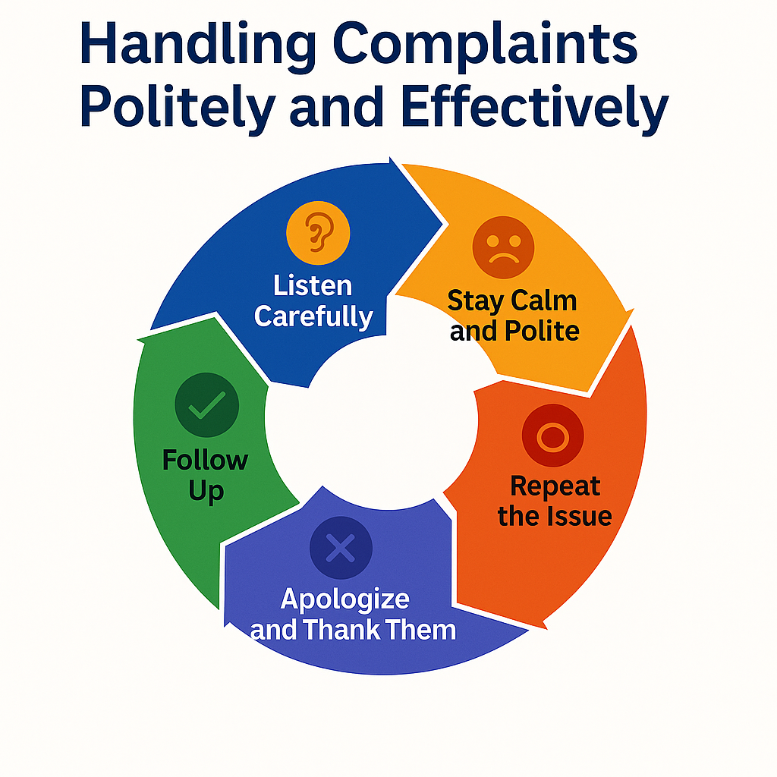

Great

Let us move to the - Maintaining repeat customers topic

**Module 3**

**Maintaining Repeat Customers**

*(Jinnar Certificate Training – Customer Service Excellence)*

**1. Why Repeat Customers Are Important**

* They give you jobs **more than once** without you having to search for new clients.
* They often recommend you to friends and family.
* They are more likely to **trust you with bigger jobs** over time.

💡 *Keeping an old customer is often easier and cheaper than finding a new one.*

# **2. Key Ways to Keep Customers Coming Back (Jinnar Standard)**

**A. Deliver Quality Every Time**

**Standard**

* Do it right the first time. No shortcuts, no guesswork.
* Use the correct tools/materials; finish with a tidy handover.

**How**

* Do a 3-point check before leaving: (1) Works as expected, (2) Area clean, (3) Customer walkthrough.
* Consider a **7-day workmanship check** (fix minor issues caused by your work at no extra charge).

**Script**

“Before I go, let’s test it together. If anything changes this week, message me—I’ll make it right.”

**B. Be Consistent and Reliable**

**Standard**

* On-time arrival window: ±15 minutes. If late, notify *before* the appointment.
* Keep promises on price, timing, and scope.

**How**

* Send a confirmation the day before; share ETA on the day.
* If something changes, propose a new plan (time/cost) and get approval *in writing*.

**Script**

“I’m running 15 minutes behind due to traffic. New ETA 9:15 AM—thank you for your patience.”

**C. Communicate Well After the Job**

**Standard**

* Follow a simple cadence: **24 hours → 7 days → 30 days** (as relevant to the job).

**How**

* 24h: “Everything okay?”
* 7d: “Any adjustments needed?”
* 30d: “I’m available for related tasks.”

**Scripts**

**24h:** “Hi Mr. Joseph—just checking the shelves I installed yesterday. Holding up well?”  
**7d:** “One-week check-in—happy to adjust if needed.”  
**30d:** “I’ll be in your area next week. Need anything looked at?”

**D. Offer Small Extras (When Possible)**

**Standard**

* Add a **quick, safe, low-cost** bonus that’s clearly related to the job.

**Ideas**

* Oil a squeaky hinge, align a cabinet door, tidy cables, wipe work surfaces, leave spare screws.
* Never add risky tasks or anything that changes scope without approval.

**Script**

“I also tightened the loose hinge as a courtesy—it should close smoother now.”

**E. Keep Records of Your Customers**

**Standard**

* Maintain a simple log so you can follow up and serve smarter.

**What to record (minimum)**

* Name, phone, address/area
* Job type, date, price, materials used
* Notes/measurements, follow-up dates, preferences

**Simple format**

pgsql

CopyEdit

Name | Phone | Job | Date | Price | Notes | 24h | 7d | 30d

**F. Show Appreciation (and Earn Loyalty)**

**Standard**

* Always thank the customer, request a review, and invite future work.

**How**

* Send a thank-you message with your name, service, and a gentle review request.
* Consider a **loyalty perk**: e.g., “5% off your 3rd job” or “free quick check on next visit.”

**Script**

“Thank you for choosing me through Jinnar. If you were happy, a quick review helps others find quality service. I appreciate you!”

**Bonus: The R.E.T.U.R.N. Framework (memorable)**

* **R**eliability — show up, keep promises
* **E**xcellence — high-quality work, clean finish
* **T**ransparency — clear prices, clear scope
* **U**pdates — before/during/after communication
* **R**ecords — track jobs, schedule follow-ups
* **N**urture — thank-yous, small extras, loyalty perks

Want this turned into a clean infographic set (checklist card + follow-up cadence + CRM log template) to slot into the Training Hub?

**3. The “3R” Formula for Repeat Customers**

1. **Reliability** – Do what you promise, when you promise.
2. **Respect** – Treat customers well in all interactions.
3. **Results** – Deliver excellent, lasting work.

**4. Common Mistakes That Lose Repeat Customers**

**1. Inconsistent Quality**

* 🔴 **Mistake:** Delivering excellent work once, then doing a rushed or careless job the next time.
* ✅ **Jinnar Standard:** Maintain the **same high quality** for every job — no matter how small. Reliability builds trust.

**2. Breaking Promises on Timing**

* 🔴 **Mistake:** Not showing up on the agreed date or time without notice.
* ✅ **Jinnar Standard:** If delays happen, **inform the customer early** with a clear reason and new schedule.

**3. Going Silent After the Job**

* 🔴 **Mistake:** Disappearing after completing work, leaving the customer unsure if you’re available for future jobs.
* ✅ **Jinnar Standard**: Always **follow up within a few days** to check customer satisfaction.

**4. Sudden Price Increases Without Justification**

* 🔴 **Mistake:** Charging more than agreed without explanation.
* ✅ **Jinnar Standard**: **Discuss and agree** on any extra costs before starting additional work.

**5. Neglecting Professional Courtesy**

* 🔴 **Mistake:** Failing to say “thank you” or show appreciation.
* ✅ **Jinnar Standard:** Treat every customer with **respect and gratitude** — this is key to long-term loyalty.

**5. Why This Is Important for Jinnar Workers**

* Repeat customers often leave **strong reviews** on Jinnar, improving your profile.
* Satisfied long-term clients help spread your name in the community, leading to **more jobs without extra advertising**.

If you like, I can prepare **a colorful “Customer Loyalty Ladder” infographic** showing the steps from first-time job → good experience → follow-up → repeat hire → long-term loyalty, all on a pure white background.

Do you want me to prepare that infographic now?

Ask ChatGPT

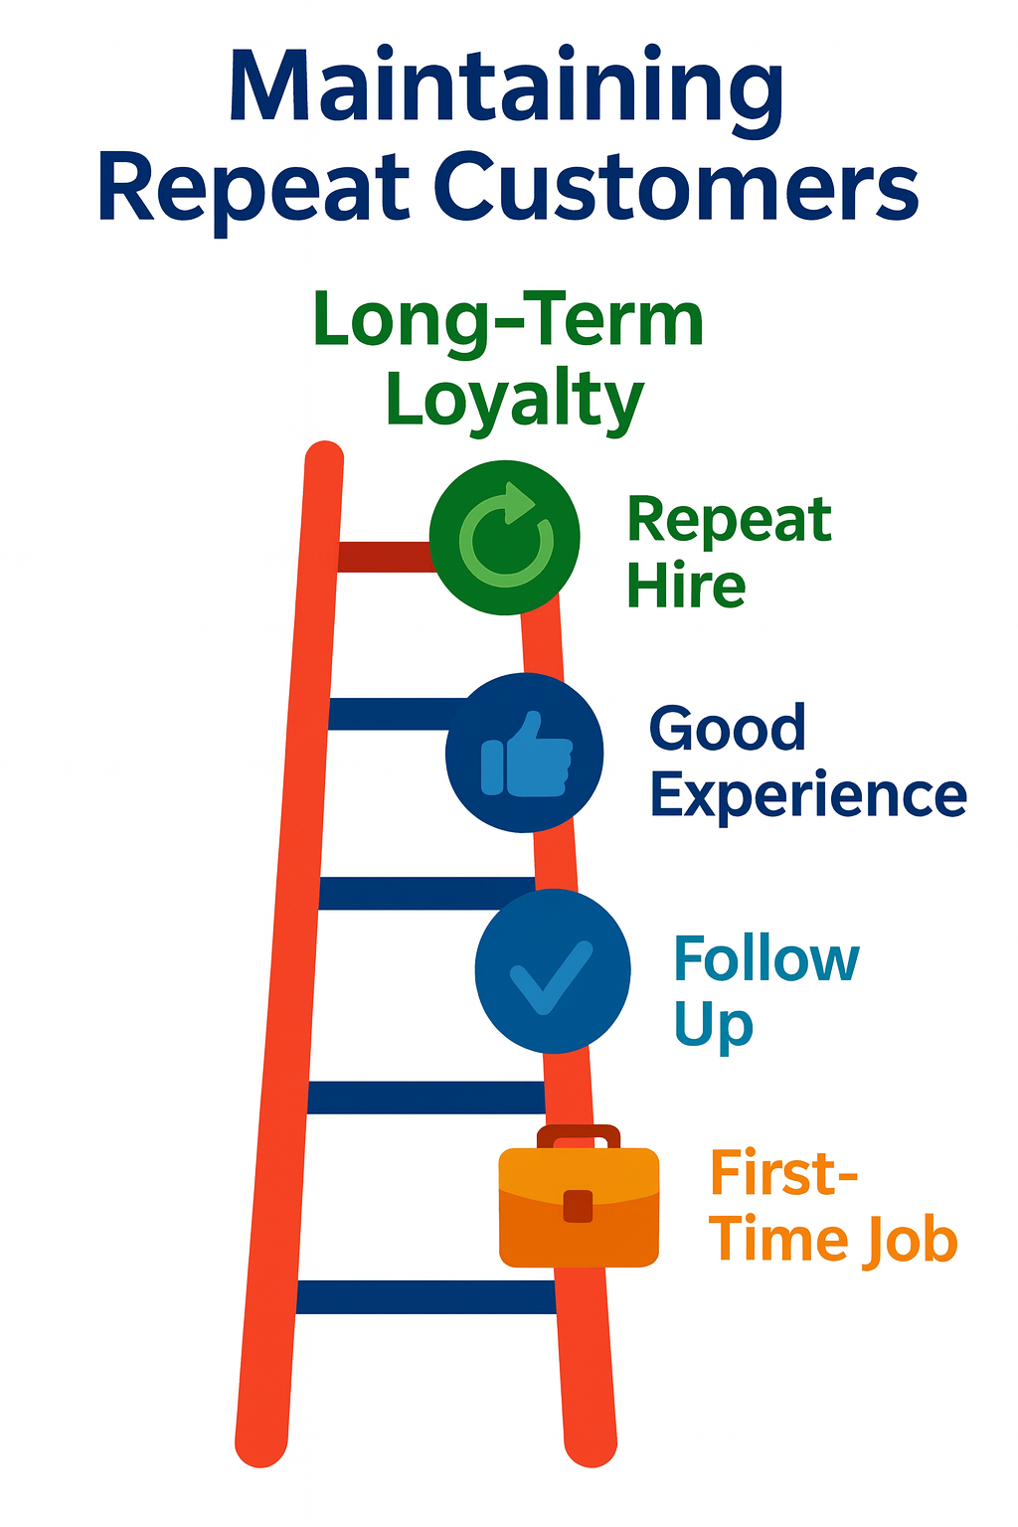

**Module 4**

**Clear Communication Before, During, and After Jobs**

*(Jinnar Certificate Training – Communication Skills)*

**1. Why Communication Matters**

Good communication prevents misunderstandings, builds trust, and ensures the job is done right.  
When clients feel informed, they’re more likely to hire you again and recommend you to others.

💡 *Clear communication = happy customers + repeat jobs.*

**2. Before the Job – *Set the Right Expectations***

* **Confirm Details**: Agree on job date, time, location, and price.
* **Ask Questions**: Understand exactly what the client wants.
* **Explain Your Process**: Tell them how you’ll do the work and how long it will take.
* **Example**: “I will arrive at 9 AM with all my tools. The work should take about 4 hours.”

**3. During the Job – *Keep the Client Updated***

* **Give Progress Updates**: Let them know how it’s going.
* **Notify About Issues**: If you find a problem or need more materials, tell them immediately.
* **Be Respectful**: Speak politely and answer questions clearly.
* **Example**: “We found a small leak in the pipe. Do you want me to fix it now? It will cost TSh 5,000 extra.”

**4. After the Job – *Leave a Good Final Impression***

* **Explain the Work Done**: Show the client what you fixed or built.
* **Give Care Tips**: Suggest how to maintain the work.
* **Thank the Client**: A simple “Thank you for trusting me” goes a long way.
* **Example**: “Your fence is now secure. Please avoid leaning heavy items on it for the next 24 hours.”

1. **Benefits of Good Communication**

**1. Fewer Misunderstandings & Mistakes**

* ✅ Clear instructions mean you understand exactly what the customer wants — saving time, money, and rework.

**2. Higher Customer Satisfaction & Ratings**

* ✅ Good communication builds trust, which translates into **better reviews, higher ratings**, and stronger platform visibility.

**3. More Repeat Jobs**

* ✅ Customers prefer to rehire workers who explain clearly, update often, and listen well.

**4. More Referrals & Word-of-Mouth Recommendations**

* ✅ Happy customers share your name with friends, family, and neighbors — growing your client base at no cost.

**5. Smoother Problem Solving**

* ✅ When issues arise, good communication makes it easier to **find solutions quickly** without conflict.

**6. Stronger Professional Reputation**

* ✅ Clear, respectful communication positions you as a **reliable and trustworthy professional** in your community.

1. **Quick Action Plan for Jinnar Workers**

*(Follow these steps every time to win trust, get good ratings, and secure more jobs)*

**1. Confirm Everything Before You Start**

* 📋 Go over the job requirements, price, timing, and materials with the client.
* ✅ Example: “So we agree I will fix the kitchen sink today for TSh 25,000, and it should take about 2 hours.”
* 🎯 Why: Prevents confusion and ensures both sides have the same expectations.

**2. Communicate Throughout the Job**

* 🕒 Update the client on progress, delays, or changes.
* ✅ Example: “The pipe under the sink is badly rusted, so replacing it will take an extra 30 minutes. Is that okay?”
* 🎯 Why: Clients feel respected and in control when you keep them informed.

**3. Deliver a Clear Handover**

* 🛠 Walk the client through the completed work and show how it functions.
* ✅ Example: “Here’s your repaired door. I replaced the hinges and oiled them — it should open smoothly now.”
* 🎯 Why: Builds confidence and shows professionalism.

**4. Show Gratitude & Invite Future Work**

* 🙏 Thank the client sincerely for hiring you.
* ✅ Example: “Thank you for trusting me with your home. I’m available anytime you need more work done.”
* 🎯 Why: Leaves a positive final impression and encourages repeat business.

**5. Record Job Details for Follow-Up**

* 📒 Note the client’s name, contact, and work done.
* 🎯 Why: Allows you to check in later, offer related services, or send greetings.

If you want, I can now create **a pure white background infographic** showing three sections:  
1️⃣ **Before the Job** – handshake & checklist  
2️⃣ **During the Job** – talking while working  
3️⃣ **After the Job** – thanking & showing results

Do you want me to design that infographic next?

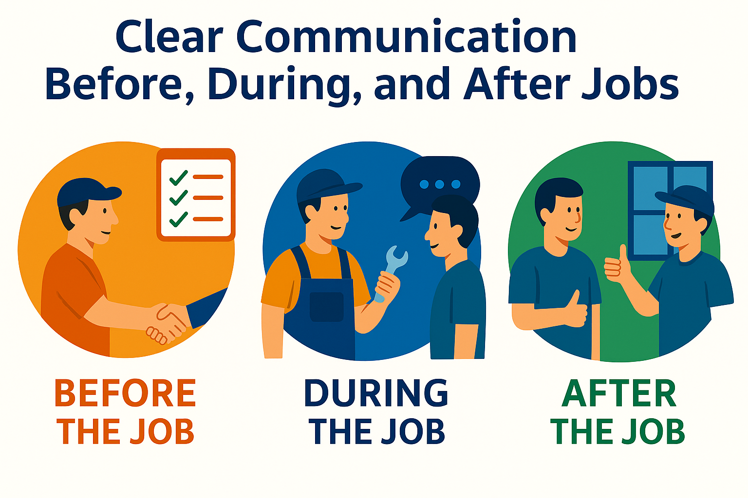

Ask ChatGPT

**Module 5**

**Delivering More Value Than Promised**

*(Jinnar Certificate Training – Customer Service Excellence)*

**1. Why It Matters**

Delivering **more value than promised** is one of the fastest ways to stand out from other workers in the informal sector.

* 🌟 **Clients remember workers who surprise them with extra care and effort** — even small gestures count.
* 💬 **Happy clients talk** — they recommend you to friends, family, and neighbors without you even asking.
* 🔄 **Repeat jobs become easier to secure** because the client already trusts your work quality and attitude.
* 🏆 **Your Jinnar profile benefits** — better reviews, higher ratings, and more visibility in searches.

💡 **Pro Tip:** In many cases, the “little extra” matters more to the client than the main job you were hired to do.

**2. What “More Value” Means**

Adding more value **doesn’t always mean doing extra work for free** — it’s about delivering **unexpected helpfulness** that makes the client smile.

**Examples of Adding Value the Jinnar Way:**

* ⏱ **Finish earlier than promised** — respect their time.
* 🔧 **Do a small extra fix** related to the job without charging (e.g., tightening a loose door handle while repairing a window).
* 📝 **Give useful maintenance tips** to help them avoid future problems.
* 🧹 **Leave the place cleaner than you found it** — organized and spotless.
* 🤝 **Be proactive** — if you notice something unsafe or broken, politely point it out and suggest a solution.
* 🎁 **Offer a small courtesy service** — e.g., oiling squeaky hinges when you’re already working on a door

Going beyond what the client expects makes you stand out.

* Clients remember workers who do “a little extra” without asking for more money.
* This builds strong trust and increases chances of getting repeat jobs.

💡 *When you surprise clients with extra value, they will talk about you and recommend you to others.*

**3. Before You Start – Plan for a Bonus Touch**

In Jinnar’s service culture, **planning a “bonus touch” before you begin** is not optional — it’s a smart habit that sets you apart.

**Step 1 – Adopt the Right Mindset**

* Ask yourself: *“What can I do today that will make this client remember me with a smile?”*
* Aim for something **practical, visible, and thoughtful** — small enough to be done easily, but valuable enough for the client to notice.

**Step 2 – Choose Your Bonus Wisely**

* Select an action that:  
  ✅ Takes **less than 10 minutes** of extra work  
  ✅ Costs you little or nothing in materials  
  ✅ Is directly or indirectly related to the service you’re providing  
  ✅ Adds **clear, visible improvement** to the client’s home, property, or comfort

**Step 3 – Examples of Bonus Touches the Jinnar Way**

* **Painters:** While painting a wall, also tighten loose switch covers or straighten a crooked wall hook.
* **Plumbers:** After fixing a leak, clean the sink area and polish the taps.
* **Electricians:** Replace a missing screw in a light switch without being asked.
* **Gardeners:** After mowing, sweep the pathway or trim a small extra section for neatness.
* **Carpenters:** Sand down a rough edge on nearby furniture while working on a separate project.

💡 **Pro Tip:** The best bonus touches are **visible improvements** that the client will see immediately, even before they test your main work.

* Think: *“What small thing can I do to make this client’s day?”*
* Choose something that costs you little time or money but is useful to them.

**Example:** If painting a room, you could also fix a loose switch cover.

**4. During the Job – Look for Opportunities**

**During the Job – Look for Opportunities**

At Jinnar, workers are encouraged to be **observant problem-solvers** — the kind who spot small issues and turn them into chances to impress.

**Step 1 – Stay Alert and Attentive**

* As you work, scan the surrounding area for **minor issues** that may affect the client’s comfort, safety, or property value.
* These could be loose fittings, signs of wear, or small cleaning needs related to your task.

**Step 2 – Communicate the Right Way**

* Politely bring the issue to the client’s attention without making them feel pressured to spend money.
* Show genuine concern for their well-being and property.  
  **Example:**  
  *"While fixing your sink, I noticed the cabinet hinge is loose. I can tighten it for you now — no extra cost."*

**Step 3 – Offer the Bonus Professionally**

* Make it clear that this is **a free extra service** you’re happy to do.
* Avoid overstepping into unrelated work unless the client approves.

**Step 4 – Examples of Smart Bonus Opportunities**

* **Plumbers:** Spot and seal a small gap in a nearby pipe bracket.
* **Painters:** Wipe a smudge or clean a paint drip on a nearby surface.
* **Gardeners:** Remove weeds from a small flower bed near where you’re working.
* **Electricians:** Replace a lightbulb if the client has one handy.
* **Masons:** Smooth a small uneven spot near the repair area.

**Step 5 – Why It Works for You**

* Clients see you as **caring and detail-oriented**.
* Increases chances of **repeat work** and **word-of-mouth referrals**.
* Helps build **higher trust ratings** on Jinnar, boosting your visibility in searches.

💡 **Pro Tip:** Even if the client says “No” to the bonus, the fact that you noticed and cared will still leave a positive impression.

1. **After the Job – Show the Extra Value**

**5. After the Job – Show the Extra Value**

Many workers miss this simple but powerful step — **telling the client exactly what you did beyond the original agreement**. If they don’t know, they can’t appreciate it.

**Step 1 – Be Clear and Confident**

* Politely explain what extra touch you added so they understand it was a bonus, not part of the agreed service.
* Keep your tone friendly and humble, not boastful.

**Step 2 – Link It to Their Benefit**

* Briefly explain why it helps them — safety, cleanliness, durability, or comfort.

**Example Statements:**

* *“I also cleaned the area around the sink after fixing the pipe so you can use it right away.”*
* *“While repainting, I tightened the loose curtain rod so it’s more secure now.”*
* *“I swept the walkway after finishing the garden work, so it’s clean and safe to walk on.”*

💡 **Pro Tip:** Pair the explanation with a quick smile and thank-you — this leaves the final interaction on a high note.

**6. Benefits of Giving More**

Going beyond the agreed service isn’t just a nice gesture — **it’s a smart business strategy** that keeps you ahead of competitors.

**A. Happier Clients**

* Clients feel they got more than they paid for, which increases satisfaction.

**B. Loyal Repeat Customers**

* People are more likely to hire you again when they remember the extra value you gave.

**C. Higher Ratings & Better Reviews**

* “Above and beyond” service often gets special mentions in online reviews, improving your visibility on Jinnar.

**D. More Referrals**

* A happy client becomes a promoter, telling friends, family, and neighbors about your service.

**E. Stronger Professional Reputation**

* Builds your image as a worker who cares about quality and client experience.

**F. Competitive Advantage**

* In crowded markets, small extra touches can make you the obvious choice over others.

**G. Personal Pride**

* Delivering more than expected boosts your own confidence and work satisfaction.

If you want, I can now **turn these two improved sections into a clean, pure-white Jinnar-branded infographic** so they visually match the rest of your training series.

1. **Quick Action Plan for Jinnar Workers**

**1. Spot an Easy Bonus Before the Job**

* Think ahead: *“What small improvement can I add without delaying the main task?”*
* Choose something related to the job and genuinely useful for the client.

**2. Deliver It With a Positive Attitude**

* Smile, stay friendly, and make the bonus feel like a natural part of your care for the client’s needs.

**3. Make Sure They Notice**

* Politely point out the extra work so they understand you went beyond the agreement.
* Keep your tone humble, not bragging.

**4. Keep It Practical and Sustainable**

* Choose extras that take little time and cost, so your main job quality and profit are not affected.
* Avoid overpromising — consistency matters more than one big gesture.

💡 **Jinnar Tip:** When clients notice small, thoughtful extras, they are far more likely to hire you again and recommend you to others.

If you want, I can now design **a pure white background infographic** showing:  
1️⃣ Promise made  
2️⃣ Extra value added  
3️⃣ Happy client → repeat jobs/referrals

Do you want me to create that infographic now?

Ask ChatGPT

Top of Form

Bottom of Form

ChatGPT can make mistakes. Check important info.

